CS 519 Cloud Computing Overview

**VL01: AWS Pricing Calculator**

School of Technology and Computing

### **Scenario 1: Web Application / Amazon Hosted RDS database/ US WEST Region**

|  |  |
| --- | --- |
| **Service** | **Data Required** |
| **Amazon Elastic Compute Cloud (Amazon EC2)** | * Two Linux t3.2xlarge instances * 20 hours per day usage * 1-Year Reserved billing with no upfront costs |
| **Amazon Simple Storage Service (Amazon S3)** | * 100 GB Standard storage * 10,000 PUT, COPY, POST, or LIST requests * 5,000 GET, SELECT, and other requests. * 1 GB data returned by S3 Select * 10 GB data scanned by S3 Select * Amazon S3 data is replicated to US East (Ohio) to S3 Standard storage. |
| **Elastic Load Balancing** | * Three Application Load Balancers * Average of 50 connections/second per Application Load Balancer. * Average connection time is 60 seconds * Average of 100 requests per second for each Application Load Balancer * Data processed per Application Load Balancer for EC2 instances with IP address as targets is 100 GB/month * Average number of rule evaluations per request is 10 |
| **Amazon Route 53** | * Five hosted zones, not using traffic flow * 10 million standard queries per month * 10,000 basic Domain Name System (DNS) health checks per month within AWS * 20,000 basic DNS health checks per month outside of AWS * 10 elastic network interfaces * Average of 2 million resolver queries per month |
| **Amazon Relational Database Service (Amazon RDS)** | * Two RDS db.r3.8xlage standard instances that run MySQL * 100 GB of General Purpose storage and no Provisioned IOPS * 30 GB of data transferred out per month and 5 GB of data transferred in |
| **AWS Support** | * Business Support |

### **Scenario 2: Data Streaming analysis / Data warehousing / Asia Pacific Region (Tokyo)**

|  |  |
| --- | --- |
| **Service** | **Data Required** |
| **Amazon Simple Storage Service (Amazon S3)** | * 50 GB Standard storage * 10,000 PUT, COPY, POST, or LIST requests * 10,000 GET, SELECT, and other requests * 100 GB S3 Intelligent-Tiering Storage (S3 Intelligent-Tiering) * 50 percent of storage is not accessed in a 30-day period * 10,000 PUT, COPY, POST, or LIST requests * 50,000 GET, SELECT, and other requests from the data stored with S3 Intelligent-Tiering * 1,000 requests per month for Lifecycle Transitions from S3 Standard into S3 Intelligent-Tiering- |
| **Amazon Redshift** | * One ds1.xlarge – 2TB-HDD master node with 1-Year No Upfront billing * Two ds1.xlarge – 2TB HDD worker nodes with 1-Year No Upfront billing. * 50 GB data scanned by Amazon Redshift Spectrum |
| **Amazon Kinesis Data Streams** | * 100 PUT records per second * Estimated record size is 500 KB * Three consumers of the data |
| **AWS Support** | * Developer Support |

### **Scenario 3: Queue based application / Analysis using Amazon Athena / Europe (Ireland) Region**

|  |  |
| --- | --- |
| **Service** | **Data Required** |
| **Amazon Virtual Private** **Cloud (Amazon VPC)** | * 100 virtual private network (VPN) connections with 50 percent utilization per month * 1 network address translation (NAT) Gateway with 50 percent utilization per month processing 100 GB per month * 100 GB transferred out per month * 10 GB transferred in per month |
| **Amazon SQS** | * 100,000 requests per month in a standard queue * 10,000 requests per month in a FIFP queue * 50,000 GB per month data transferred out * 20,000 GB per month data transferred in |
| **Amazon DynamoDB** | * 1 TB dataset   On-demand capacity   * 5-KB item size * Eventually consistent reads * 4 million items read per month * 2 million transactional items read per month * 2 million items written per month * 1 million transactional items written per month * 1 million replicated writer per month using on-demand global tables * 100 GB of on-demand data backup |
| **Amazon Elastic File** **System (Amazon EFS)** | * 100 GB of data stored in standard storage * 50 GB stored in infrequently accessed storage * 10 MBps of provisioned throughput |
| **AWS Support** | * Enterprise Support |

**Where do I access the AWS Pricing Calculator?**

[https://calculator.aws/ (Links to an external site.)](https://calculator.aws/)

**Once you have completed your analysis using the AWS Pricing Calculator use the associated discussion thread to summarize your solution and describe why some of the parameters required by the calculator are important and evaluate your solution.**

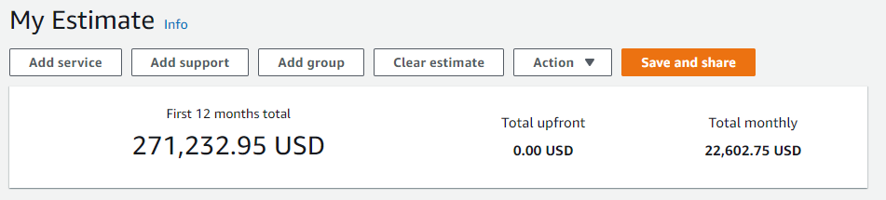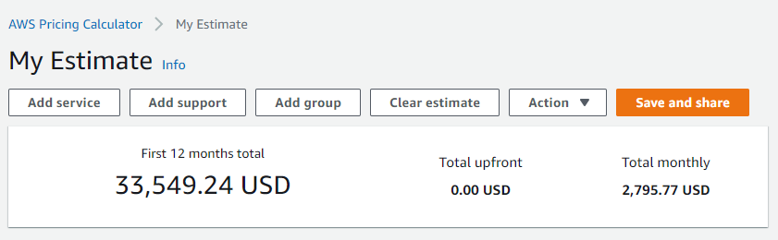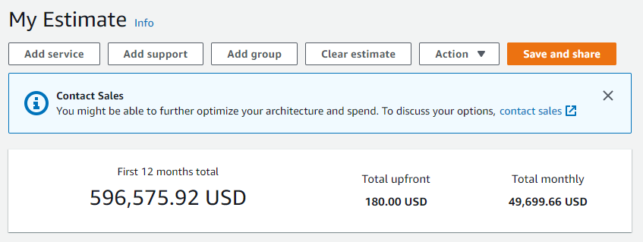Even though we were told that we don’t need to guess capacity or worry about anything else, here we can see that we need to know what we need so we can purchase that configuration. Of course with cloud computing, decreasing or increasing resources is easier, but we still need to think about what we need and how much of it we need.